This Is How You Can Boost Flavor Across the Menu
How restaurants can easily pack big tastes into their dishes.
SPONSORED CONTENT | JUNE 6, 2018

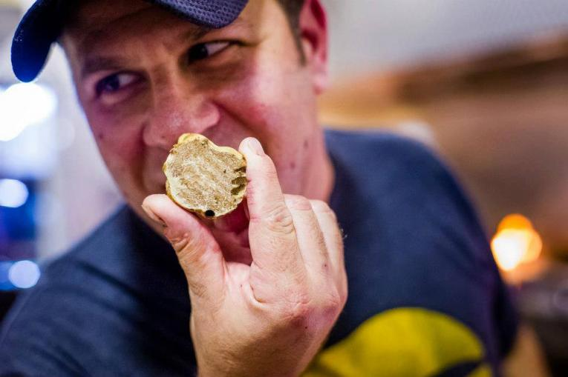
ADAM FLEISCHMAN
Adam Fleischman uses animal fats to help him capture bold flavor profiles.
Sponsored by Coast Packing Company.
Umami Burger founder Adam Fleischman literally wrote the book on bold flavors, so it should come as no surprise that he looks for ways to boost the taste profiles of his food. One incredibly effective method he’s found is to use animal fats.
Animal fats have been uses for centuries to cook foods and impart flavor, but some cooks have been hesitant to use animal fats in the U.S. This has stemmed from the fact that recent generations of Americans haven’t been exposed to as many animal fats. “American cultures generally grew up with margarine and canola and things like that that are much more neutral in flavor, and I don’t think they are familiar with animal fats,” Fleishman says.
Many of these products fell out of favor with the public in the past few decades when it was believed that they were unhealthy for humans. Chefs and home cooks used plant-based products like canola and partially hydrogenated soybean oil as a substitute. Research in the last few years has shown that this perception of animal fats as unhealthy may not be entirely accurate. As a result, some cooks, restaurants, and even grocery stores are beginning to once again embrace animal fats.
“One of the biggest misconceptions is that animal fats are unhealthy,” Fleischman says. “I think they will become more accepted. Just look at the 70s and 80s when research said that animal fats were unhealthy and people switched to margarine instead of butter. Since then, people have realized margarine was less healthy, so they’ve gone back to butter—an animal product—and you don’t see margarine on menus anymore.”
ADAM FLEISCHMAN
This perception is changing so fast that Fleishman says he can now find animal fats in a strictly organic health-focused grocery store near his house. “They now carry a new line of all-natural cooking fats, and you can buy pork and duck fat in jars to cook with, so animal fats are definitely becoming more accepted.”
More importantly, however, animal fats offer a bold flavor profile that’s difficult to recreate with animal-based products. Fleischman’s favorites include duck and goose fat, pork lard, and beef tallow because he likes the depth of flavor they provide. In his forthcoming book, Flavor Bombs: The Umami Ingredients That Make Taste Explode, he includes a recipe for salmon poached in goose fat and served with truffle sauce. “The goose fat doesn’t make the fish greasy or fatty–it’s just a way of cooking that imparts flavor.” He also says that he uses animal fats in his restaurants when appropriate.
As animal fats regain popularity amid health research, American chefs and cooks can gain more experience using these products by exploring various animal fat product available, he says. Traditional pairings and ethnic dishes that already use animal fats can be great starting points. “Once cooks start exploring other cuisines, like French or Mexican cuisine, they discover uses for animal fats,” Fleischman says. “I think the best way is to start with the traditional pairings and go from there. Pork rillettes are traditionally covered with white, creamy lard, and potatoes are often roasted in goose fat. Pork fat is traditional in Mexican food, and carnitas are traditionally cooked in a copper cauldron with lard. Start with the traditional and branch out from there.”
Animal fats also appeal to customers, and restaurants can entice diners to order dishes by using menu call outs. “You are seeing beef fat or beef tallow fries increasingly on menus, and when people see beef fat fries with truffle and Parmesan they get excited. You don’t see that with canola oil fries.”
Animal fats also allow chefs to use more parts of the animal, increasing the environmental sustainability of cooking with animal products, and they provide operational efficiencies. Food, like pork belly confit, can be cooked in lard and then preserved for a long time in the fat itself. Additionally, animal fat can be melted and reused.
At the end of the day, though. It all comes down to flavor for Fleischman. “Animal fats add umami to certain dishes with the savory taste,” Fleischman says. “They provide really incredible flavor.”
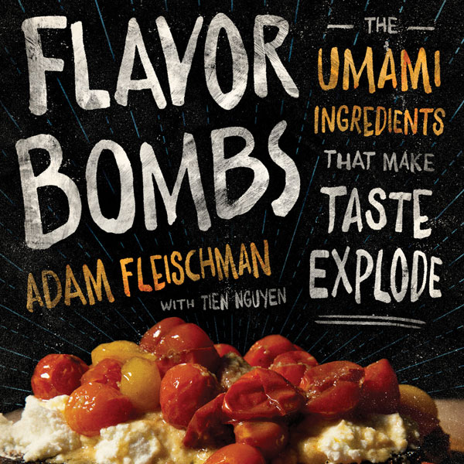
Adam Fleischman’s new book, Flavor Bombs: The Umami Ingredients That Make Taste Explode, will be released on May 15 and can be pre-ordered now on Amazon.
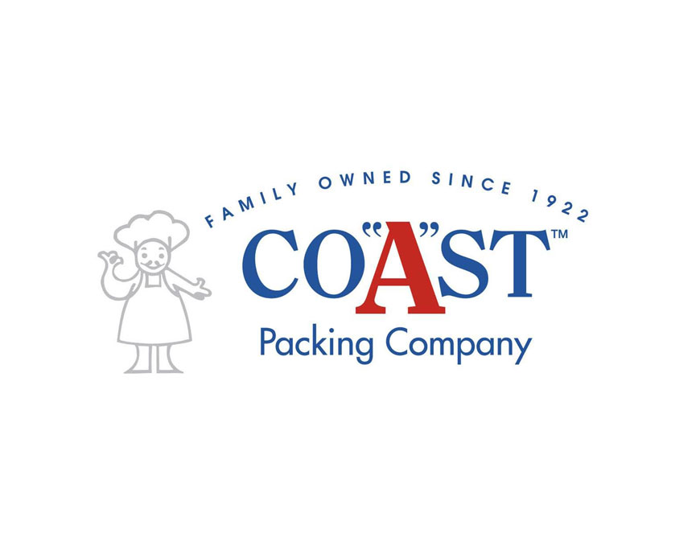
Now marking its 96th year in business, Coast Packing Company, is the number one supplier of animal fat shortenings—particularly lard and beef tallow—in the Western United States. The company sells to major manufacturers, distributors, retailers, smaller food service operations, and leading bakeries. The company participates actively in various ethnic markets, from Hispanic retail chains, with its VIVA brand, to various Asian specialty markets. Coast is a founding member of the Healthy Fats Coalition.

